**SWAPPING OF NUMBERS**

**EXP NO: 15**

**AIM:** To compute swapping of numbers using 8085 processor.

**ALGORITHM:**

1) Load a 8-bit number from memory location into accumulator.

2) Move value of accumulator into register H.

3) Load a 8-bit number from next memory location into accumulator.

4) Move value of accumulator into register D.

5) Exchange both the registers pairs.

6) Halt

**PROGRAM:**

LDA 2001

MOV B,A LDA 2002

STA 2001

MOV A,B

STA 2002

HLT

**INPUT:**

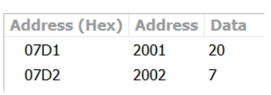

**OUTPUT:**

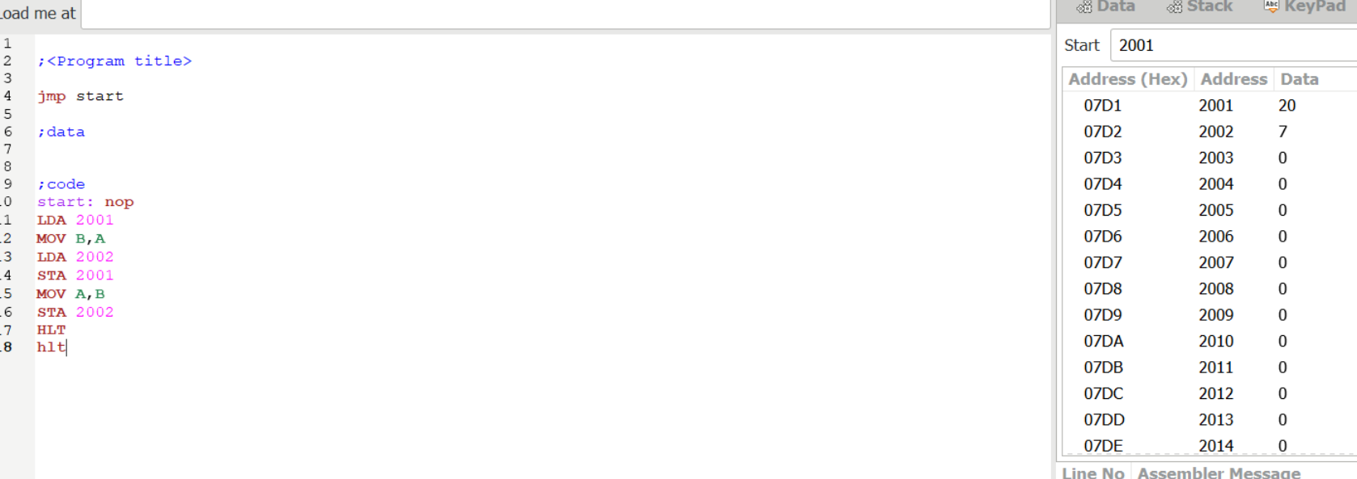

**RESULT**: Thus the program was executed successfully using 8085 processor simulator.